SISMUN VI  2019 | The venezuela  conflict

Venezuela Conflict
Security Council: The Security Council is encompassed by 15 members, each one of those members get one vote. Five out of the fifteen members are permanent members, also known as the P5. The permanent members are the United States, France, Russia, United Kingdom, and China. All the permanent members are granted veto power when voting on resolutions. Overall, the security council focuses on maintaining international peace and security by identifying and discussing international threats.
Overview:
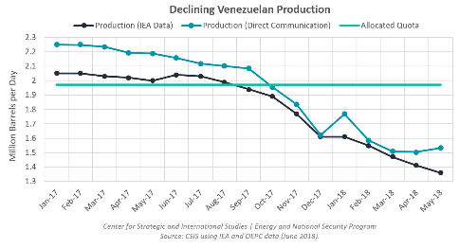
Venezuela, what was once the richest country in South America and among the top 20 richest countries in the world, is now suffering from extreme poverty and hyperinflation. Since the day Hugo Chavez took power in Venezuela, the government and most importantly the country gradually began to experience a downfall. As the years passed Chavez focused more and more on transitioning the country into the grasps of communism, little did he know that his cherished ideology would cause the downfall of his country. The oil industry used to supply the country with a huge part of its revenue. However as more and more socialist reforms were enacted in the country by Chavez, the oil sector would begin to suffer. Chavez would get rid of the private sector entirely, thus everything was owned by the government. At the time, the government owning everything was absolutely fine, but once oil prices began to drop by almost 50% then it became a problem as government revenue became affected. Without a private sector the country had nothing to make up for the drop in oil prices thus the economy began to suffer. Additionally, Chavez refused to invest in the oil industry’s infrastructure which again would continue the lack of sufficient government revenue. When Chavez died in 2013, the country was already suffering from the effects of the weakening private sector and economy. Nicolas Maduro, also a socialist, would take office and completely destroy the economy, social, and political life of the once richest country in South America. Maduro failed to rally Chavistas like Chavez had done, which caused much social unrest in the country as the falling oil prices began to hamper Venezuela's already degrading economy. The country’s private sector has completely crashed to the point where it is basically non-existent, Maduro didn’t fund or expand the sector and got rid of all the competent workers of the sector. Since the private sector was not expanded, Venezuela became more dependent on the oil industry, however the oil prices have fallen and Venezuela's oil production has decreased as well, due to underfunding of the industry’s infrastructure, this has caused the country’s economy to completely crash. The country is suffering from hyperinflation, resulting in their currency, Bolivars, to become basically worthless. As the situation became worse, the lack of food and resources has caused people to hit the streets to express their discontent and anger towards the government, resulting in much chaos and an increase in crime. The opposition party and people continue to protest however they haven't had much success, since the government refuses to listen and Maduro refuses to give up power. Additionally, Venezuela’s refugee crisis cannot be ignored. About 4 million Venezuelans have fled the country into neighboring countries such as Ecuador and Colombia. People continue to leave Venezuela to escape violence, insecurity and threats as well as lack of food, medicine and essential services.

A Dictator is Born:
Nicolas Maduro, the current president of Venezuela, took power after Hugo Chavez. As the country’s economy continues to degrade, the protests continue. 90 % of the Venezuelan people no longer support Maduro and want him out of power, however he continues to rig the country’s election thus maintaining himself in power without the consent of the people.

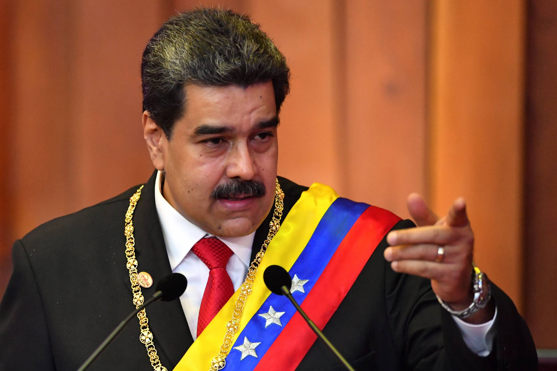

The Population:
The people of Venezuela are constantly hitting the streets in order to protest the existence of Maduro’s totalitarian regime. They protest his inability to lead and the extreme poverty that the country is experiencing. There is food scarcity, lack of electricity, the currency is worth little to nothing, and there are no resources. In other words, the country is complete chaos and violence as people try to push for his exit out of power and he continues to refuse.
Questions to consider:
- From a humanitarian perspective, what should the global community do to assist Venezuela and its people?
- Should Maduro be forced out of power, or is there a diplomatic solution to this? Is he an illegitimate leader?
- How can Venezuela’s currency and economy be repaired?
- How welcoming should neighboring countries, or more developed countries, be of Venezuelan refugees?

Countries:
- United States
- China
- Russia
- United Kingdom
- France
- Venezuela
- Opposition party (voting member)
- Colombia
- Brazil
- Mexico
- Uruguay
- Peru
- Germany
- Cuba
- Dominican Republic
- Argentina
- Chile
- Nicaragua
- El Salvador
- Bolivia

